**Web computing project-part4**



Car advisor

**Group members:**

* [**Mohammed Al Riyam**](mailto:s138985@student.squ.edu.om)**[leader] s138985**
* **Mohammed AL Harthy s138970**
* **Mohammed AL Tamami s141612**

**Table of content:**

1) Overview 3

2) Creating Database using MySQL Database: 3

3) SQL codes: 5

4) PHP codes 8

5) Retrieve Data from all XHTML forms in previous parts of the project: 13

6) Display result of using the SQL and PHP codes………………………………………….15:

7)Website hyperlink: 16

Members contribution: 16

**Overview:**

in this part of the project, we continued the process of making a full stack website. After finishing the HTML\ CSS \ JS elements of the project, we know focus on the server side of the project by creating databases, and PHP codes to contact the server side of the project with the client side. Moreover, we created multiple databases for our websites for every element that consist of elements that needed to retrieve data from the user. This data sets are added to their SQL database using PHP code.

## **1)****Creating Database using MySQL Database**

The structure and contents for four tables—car_calculations, feedback, fun_scores, and users—are contained in this PHPMyAdmin SQL . Information about automobile purchases, such as the purchase price, user ID, and calculation date, is kept in the car_calculations table. User feedback and submission dates are noted in the feedback table. Game scores and completion times are recorded in the fun_scores database. Finally, user credentials such as passwords, emails, and usernames are stored in the users table. Every table has a primary key, and certain tables are linked by foreign key constraints.

* Overview of the databases established for our project:
* 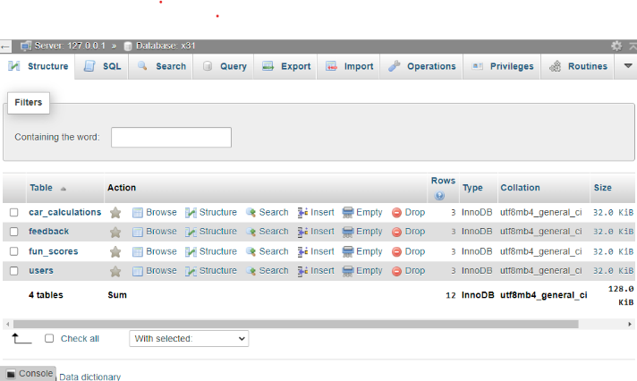
* A screenshot of a computer

  Description automatically generated

**

## **SQL codes:**

## X31.sql:

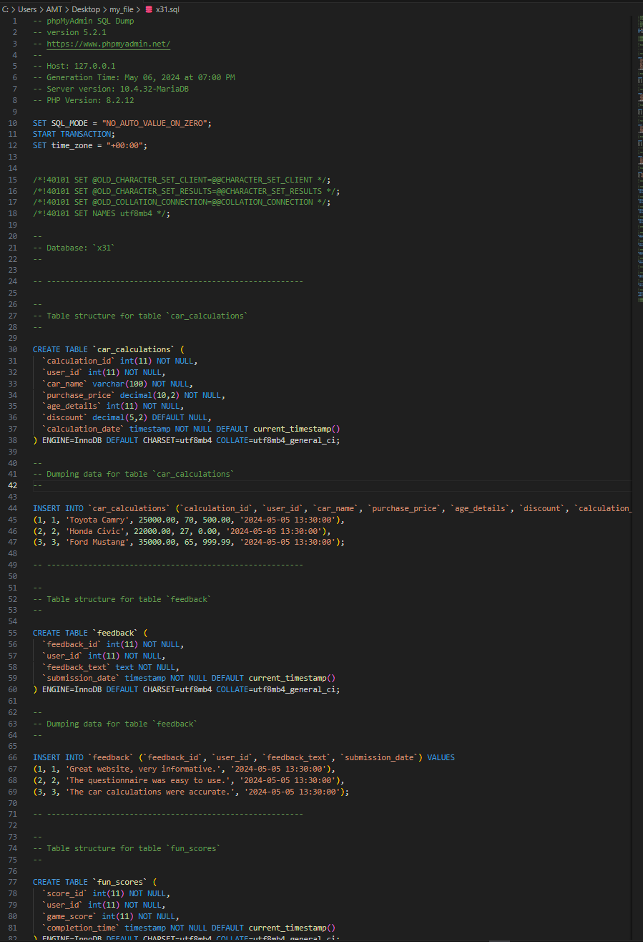

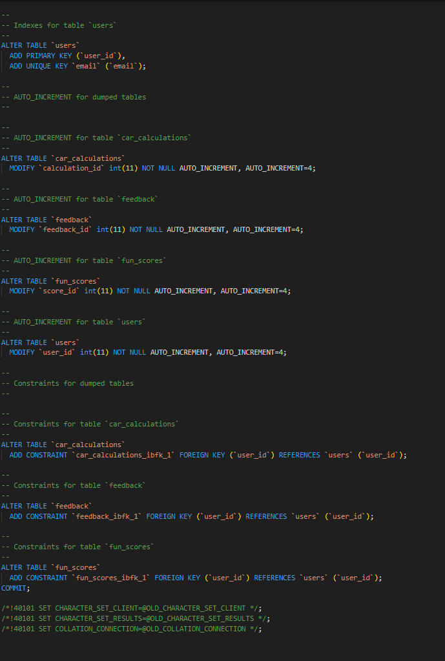

* **feedback.sql**
* A screenshot of a computer

  Description automatically generatedA screenshot of a computer

  Description automatically generated
* **Car(1).sql**

* **Players.sql:**

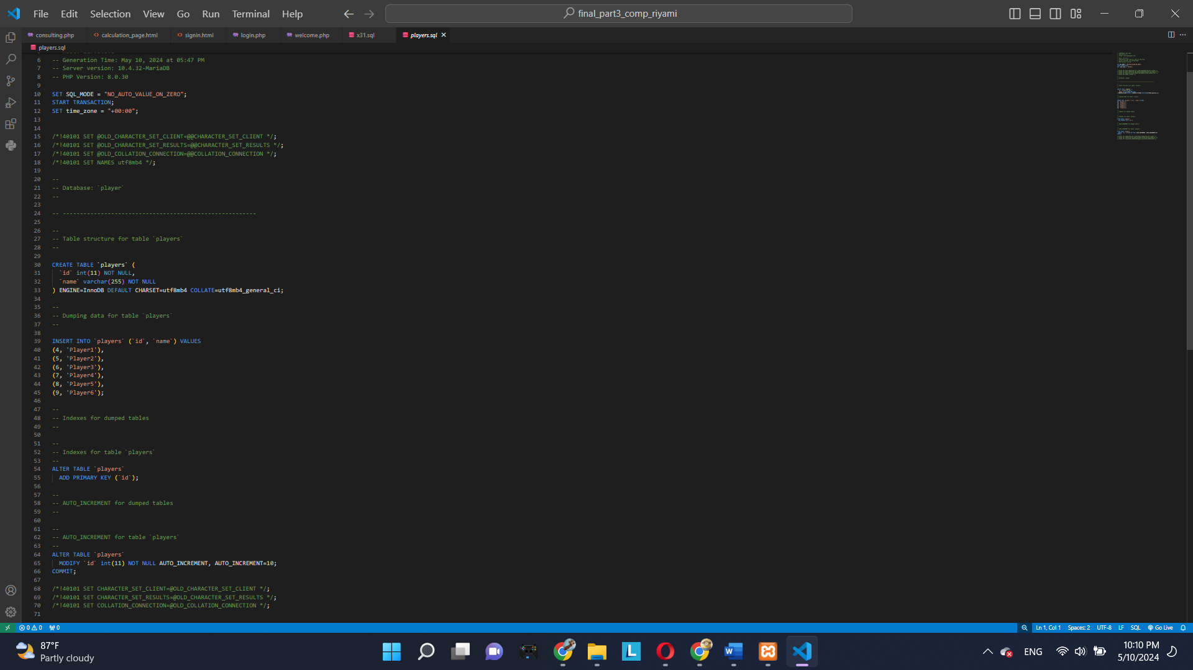

**2) PHP codes:**

**Consulting.php:**

**Feedback.php:**

**funPage.php:**

**Index.php:**

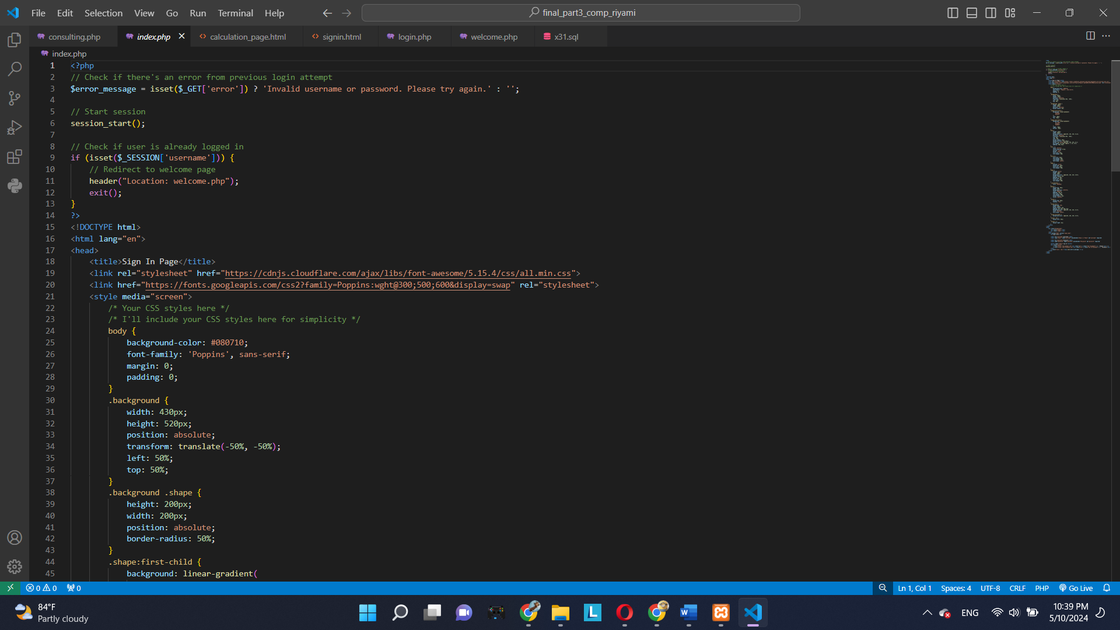

**Login.php:**

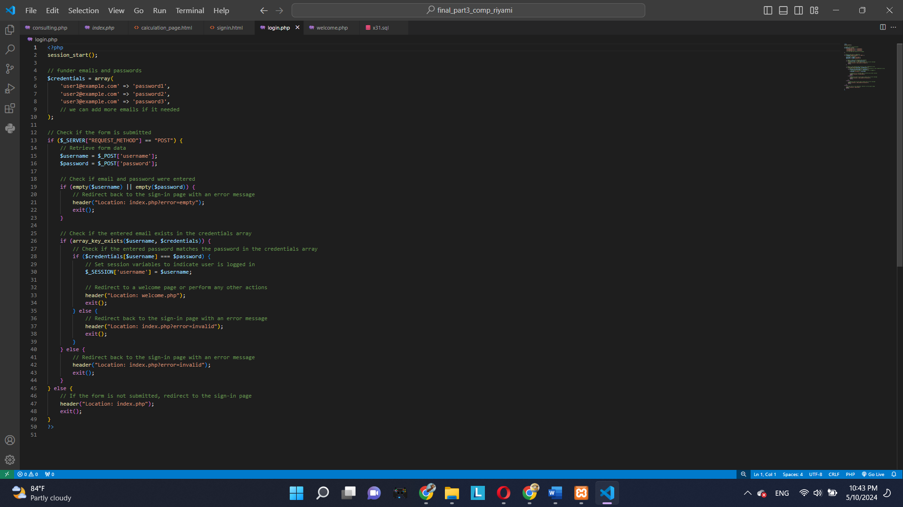

**Welcome.php:**

**3)** **Retrieve Data from all XHTML forms in previous parts of the project:**

1. 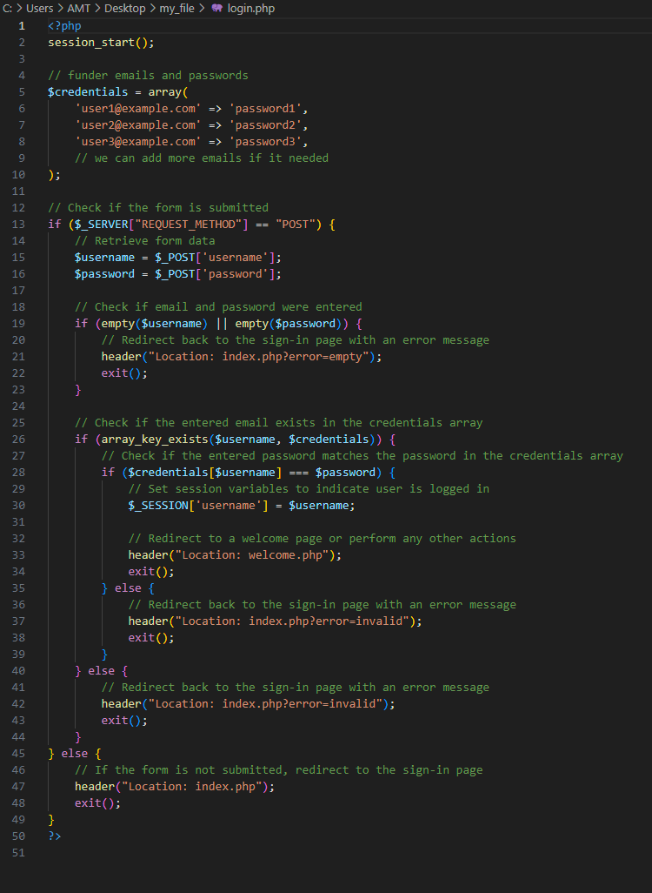We created the sign-in page to enhance user experience, utilizing PHP to gather email and password data. The PHP file then verifies if the email and password are in the array; if they are, the user is logged in. Additionally, we restricted sign-in access to founders only, as regular users do not require sign-in privileges. Since users only need to provide their email and phone number when purchasing a car, signing in offers no benefit to them. Upon successful login, users are directed to the welcome page, from which they can navigate to the calculation page by pressing a designated button.  
   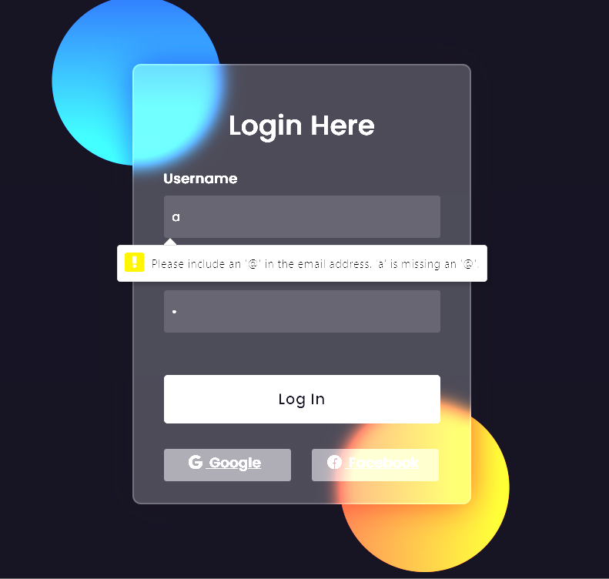A screenshot of a computer

   Description automatically generated

**Display result of using the SQL and PHP codes to access, store and process users data:**

## **Website hyperlink:**

We host our website on <https://dash.infinityfree.com/> which offers a free plan to publish your website without any ads.

The link to our website is <http://caradvisor.000.pe/> . Moreover, most of our work was done through github using a repository to collaborative coding.

Github link:<https://github.com/moalharthy/car-advisor>

## **Members contribution:**

|  |  |
| --- | --- |
| Mohammed AL Riyami | * Adding the functionality of add/delete to the databases. * Project report * Combining the code to the final result for the submission. |
| Mohammed AL Harthy | * Created data bases to insert players in fun pages * Data base for car consulting * Data base for customer’s feedback |
| Mohammed AL Tamami | * Creating Database using MySQL Database. * Sign in page + welcome page > php + html. * Help on the Report. * Purchase on calculation page. |